MACHINE LEARNING

LAB-5

NAME: DURGAM NAGA DEERAJ REDDY

USN: 22BTRAD013

Q. Implementing Logistic Regression.

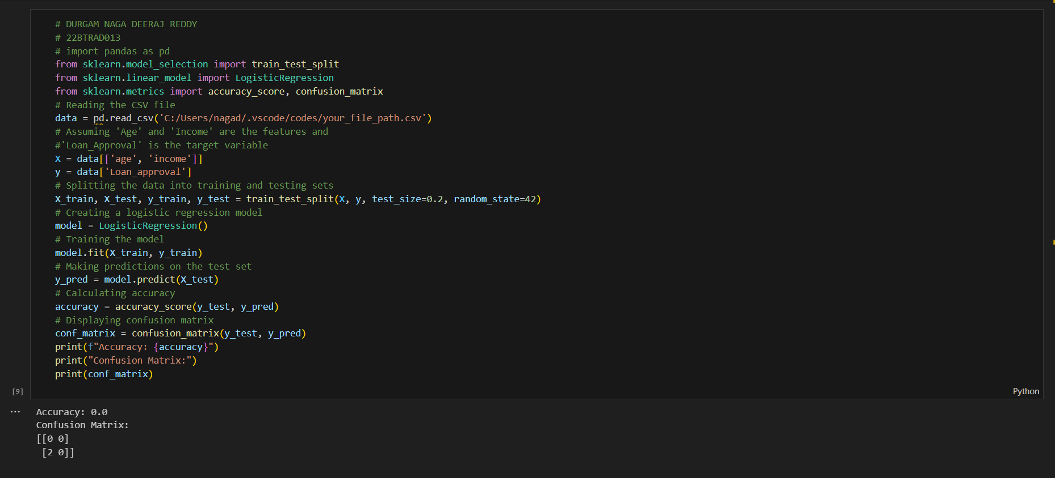

**CODE:**

# DURGAM NAGA DEERAJ REDDY

# 22BTRAD013

# import pandas as pd

from sklearn.model_selection import train_test_split

from sklearn.linear_model import LogisticRegression

from sklearn.metrics import accuracy_score, confusion_matrix

# Reading the CSV file

data = pd.read_csv('C:/Users/nagad/.vscode/codes/your_file_path.csv')

# Assuming 'Age' and 'Income' are the features and

#'Loan_Approval' is the target variable

X = data[['age', 'income']]

y = data['Loan_approval']

# Splitting the data into training and testing sets

X_train, X_test, y_train, y_test = train_test_split(X, y, test_size=0.2, random_state=42)

# Creating a logistic regression model

model = LogisticRegression()

# Training the model

model.fit(X_train, y_train)

# Making predictions on the test set

y_pred = model.predict(X_test)

# Calculating accuracy

accuracy = accuracy_score(y_test, y_pred)

# Displaying confusion matrix

conf_matrix = confusion_matrix(y_test, y_pred)

print(f"Accuracy: {accuracy}")

print("Confusion Matrix:")

print(conf_matrix)

**RESEARCH ON LOGISTIC REGRESSION:**

Logistic Regression is a statistical method used for modelling the probability of a binary outcome. Despite its name, it's commonly employed for classification tasks rather than regression.

The algorithm predicts the probability that an instance belongs to a particular category. Logistic Regression is a foundational algorithm in machine learning and is particularly useful when dealing with binary classification problems.

**REQUIRED MODULES FOR LOGISTIC REGRESSION:**

We import necessary libraries:

• pandas: For data manipulation and analysis.

• train_test_split: To split the dataset into training and testing sets.

• LogisticRegression: Implementation of logistic regression from scikit-learn.

• accuracy_score and confusion_matrix: Metrics to evaluate the performance of the model

**GITHUB LINK:**

https://github.com/DeeruReddy/Machine_learning